Post-Flight Performance Report

Kent State University High-Power Rocket Club

Kent State University

Team Mentor: Mr. Steve Eves

Team Faculty Advisor: David B. Stringer, Ph.D.

dstring1@kent.edu 330.672.3953

Team Program Manager: Nelson Figueroa, AET

nfiguer2@kent.edu 330.423.5885

Team Members:

Adam Fertig; Safety Officer; afertig1@kent.edu, AE (330) 842-3396

Kaushik Anantha; Data Acquisition Team Lead; kanantha@kent.edu, AE (410) 802-7020

Alex Gajowski, CS

Michael Garlak, CS

Timothy Park, CS

Nick Stahl; Structures Team Lead; nstahl2@kent.edu, AET (706) 249-6251

Maddie Wilson, MECH

Zack Helfer, AE

Nina Patterson; Propulsions Team Lead; npatter5@kent.edu, PH (330) 671-7737

Adrian Rivera, AE

Shawn George, FT

Sydney Bihn, AE

Tyler Williams, AE

AE: Aerospace Engineering

AET: Aeronautical Systems Engineering Technology

CS: Computer Sciences

FT: Flight Tech

MECH: Mechatronics Engineering Technology

PH: Public Health

**Table of Contents**

Table of Tables & Figures...............................................................................................................3

Competition Photos..........................................................................................................................4

Rocket Operation Assessment.........................................................................................................5

Flight Anomalies Analysis.........................................................................................................5

Propulsion System Assessment.................................................................................................5

Flight Trajectory Assessment....................................................................................................5

Recovery System Assessment....................................................................................................7

Ground Recovery Assessment...................................................................................................7

Pre- & Post-Launch Procedure Assessment..............................................................................7

Actual vs. Predicted Performance....................................................................................................7

Peak Altitude Comparison to Expectations...............................................................................7

Peak Velocity Comparison to Expectations...............................................................................9

Peak Acceleration Comparison to Expectations......................................................................10

Descent Velocity Comparison to Expectations........................................................................11

Active Roll System Data Collection & Analysis...........................................................................12

Roll Monitoring Data Presentation..........................................................................................12

Quality of Flight Video............................................................................................................12

Flight Video Links...................................................................................................................13

Data Interpretation & Comparison to Expectations.................................................................13

**Table of Tables & Figures**

Table 1: Predicted vs. Actual Altitude.............................................................................................8

Table 2: Predicted vs. Actual Velocity............................................................................................9

Table 3: Predicted vs. Actual Acceleration....................................................................................10

Table 4: LED Instruction...............................................................................................................12

Figure 1: Kent State University’s High-Power Rocket Club...........................................................4

Figure 2: Competition Flight Line...................................................................................................4

Figure 3: Mark Rollberg..................................................................................................................4

Figure 4: Average Vertical Flight Trajectory..................................................................................6

Figure 5: TeleMetrum v2 Average Vertical Flight Trajectory........................................................6

Figure 6: J800T-L Launch #3 Predicted Altitude v Time................................................................8

Figure 7: J800T-L Launch #3 Actual Altitude v Time....................................................................8

Figure 8: J800T-L Launch #4 Actual Altitude v Time....................................................................8

Figure 9: J800T-L Predicted Velocity v Time.................................................................................9

Figure 10: J800T-L Launch #3 Actual Velocity v Time.................................................................9

Figure 11: J800T-L Launch #4 Actual Velocity v Time...............................................................10

Figure 12: J800T-L Predicted Acceleration v Time......................................................................10

Figure 13: J800T-L Launch #3 Actual Acceleration v Time.........................................................10

Figure 14: J800T-L Launch #4 Actual Acceleration v Time.........................................................11

Figure 15: Predicted v Actual Parachute Descent Rates................................................................11

**Competition Photos**

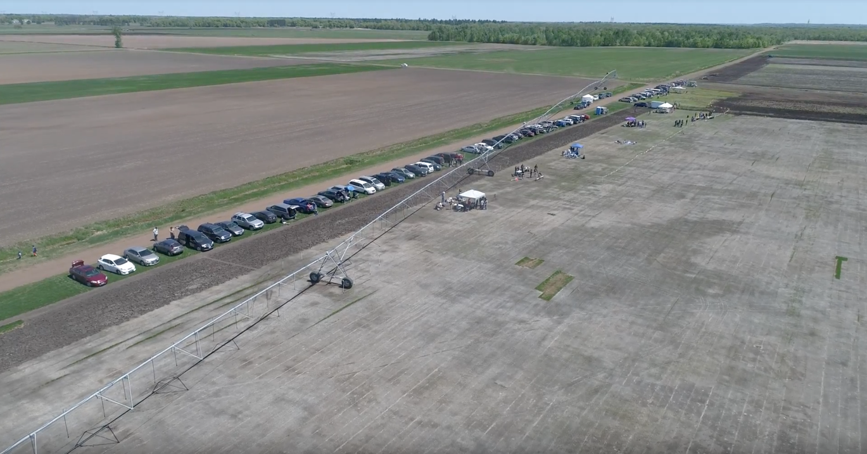

*Figure 1: Competition Flight Line*

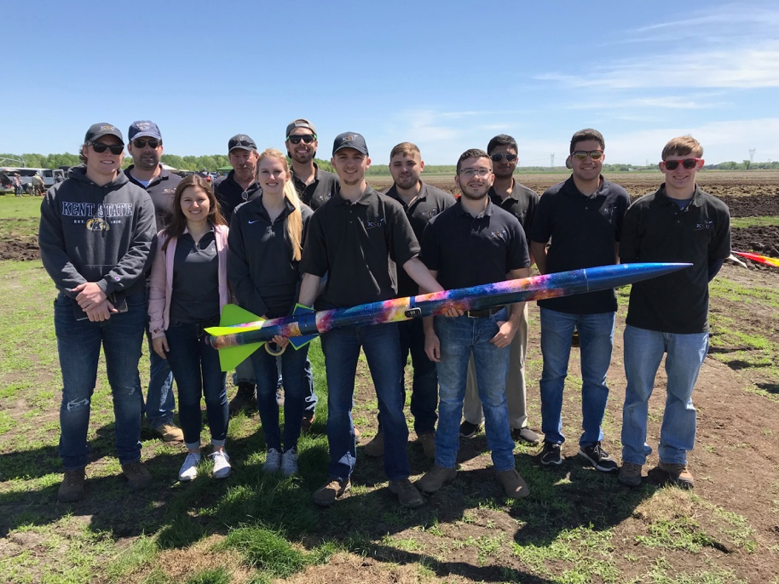 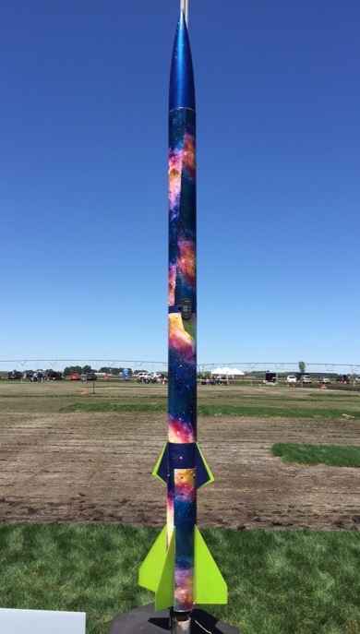

*Figure 2: Kent State University’s High-Power Rocket Club Figure 3: Mark Rollberg*

**Rocket Operation Assessment**

**Flight Anomalies Analysis**

A few anomalies occurred during our launches. In our first launch, one second into the video, the LED changed from solid to completely off. This indicates that the system detected launch and made no attempt to eliminate roll, as per competition rules, during boost phase. After motor burn, and the two second time delay, the LED indicator did not turn back on. This problem had not been encountered during test launches. We speculated that the problem was the SD card being ejected from the reader when entering negative g-force at motor burnout. Further ground inspection revealed that this was not the problem as the roll system continued to work even after the SD card was removed from the reader. Our current conclusion is that the entire system powered off and was unable to properly restart. This issue only occurred on our first competition launch.

During our second launch, the roll system never detected launch. This caused the canards to lock into their zero position for the entire flight. This issue had occurred twice during test launches and seems to have something to do with the timing of the launch detection pull pin. The Arduino appears to miss the event and never notices the pin update. To remedy this issue, we added an additional launch detection trigger of an acceleration of greater than 13 m/. During our third and fourth competition launches, the roll system performed as expected regardless of if launch was triggered by acceleration or the pull pin.

In each of our launch videos, mainly the fourth, it is very apparent that the drogue chute deploys a few feet below apogee. This problem had not occurred during this year’s test launches but was caused by a difference in apogee readings from our primary and secondary altimeters. Our primary altimeter, StratoLoggerCF, recorded an apogee of 10 to 20 feet lower than our secondary, TeleMetrum v2. This is the cause of our early drogue chute ejections. A future fix to this anomaly will be to purchase a new StratoLoggerCF, launch it with the old one, and compare data.

While recording launch data at the competition, we noticed that both the judges and our own Altimeter 2 were recording a large descent rate. The data showed that our 42-inch drogue and 80-inch main chutes were giving a descent rate of 34 feet per second. This was not the case during our test launches. Our average descent rate during test launches was around 18 feet per second. When cross-referencing with our TeleMetrum v2 and Altimeter 3, we found all competition descent rates to be 15 to 18 feet per second. A future fix will be to use the Altimeter 2 as a backup to out Altimeter 3.

**Propulsion System Assessments**

The J800 performed as expected during each flight with no unexpected anomalies caused by the motors. All four flights were logged successfully using the TeleMetrum v2, StratoLoggerCF, two Altimeter 2s, and one Altimeter 3.

**Flight Trajectory Assessment**

The rocket maintained a vertical trajectory with slight deviations in angle for each flight.  This angle deviation was caused by differing launch rod angles. There were no problems involving the rocket flying off in its own direction throughout our 17 launches this year.  This was due to our fail-safe canard system which allows only one angle to be reached by both canards at any given time. *Figure 4* below shows our average flight trajectory.

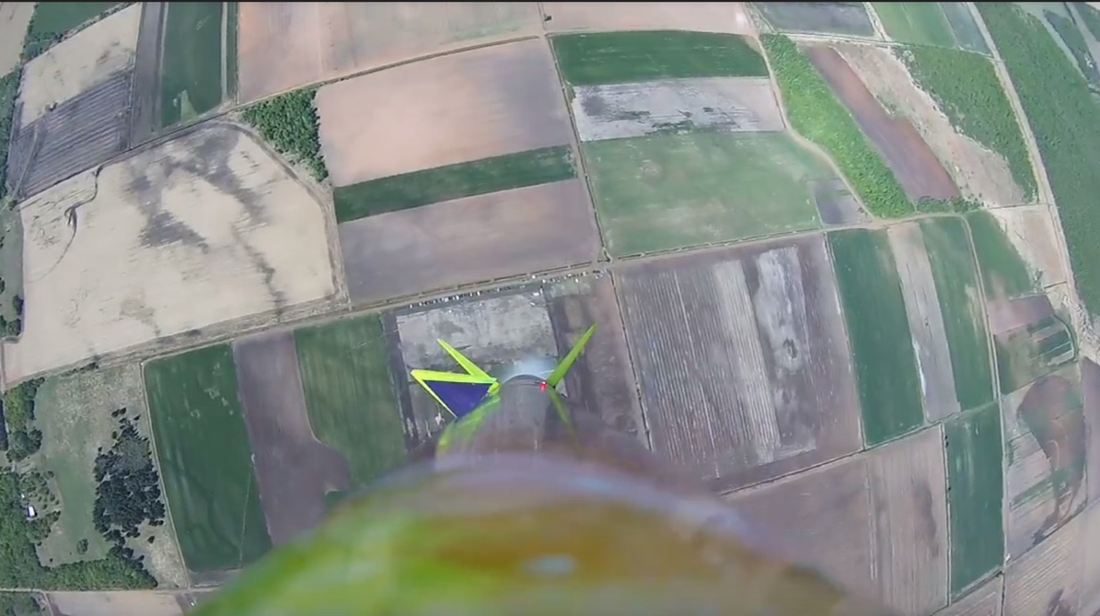

*Figure 4: Average Vertical Flight Trajectory*

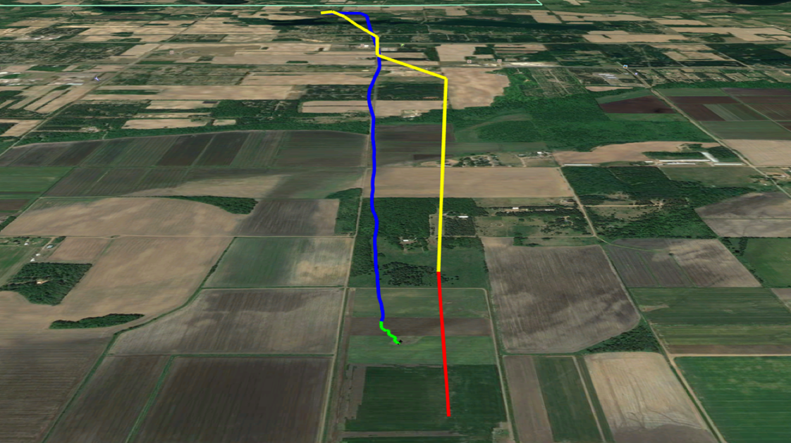

*Figure 5: TeleMetrum v2 Average Vertical Flight Trajectory*

**Recovery System Assessment**

The recovery system was reset upon arrival at the launch site.  We replaced our Nomex sheets due to wear and tear occurring over the course of our test launches. The dual deploy recovery system performed as expected with no anomalies in the black powder charges, but one anomaly with our parachute deployment. Our drogue parachute was set to deploy at apogee and the main parachute was set to deploy at 500 feet. We set the main parachute to deploy at this altitude because we used an 80-inch main parachute to ensure proper decent speeds. The drogue chute deployed a few feet below apogee during each competition launch. This is most noticeable in our fourth competition launch video. This problem had not occurred during this year’s test launches but was caused by a difference in apogee readings from our primary and secondary altimeters. Our primary altimeter, StratoLoggerCF, recorded an apogee of 10 to 20 feet lower than our secondary, TeleMetrum v2. This is the cause of our early drogue chute ejections.

**Ground Recovery Assessment**

Pre- and post-launch procedures went smoothly on all four competition launches. We developed an extremely thorough checklist to ensure both launch procedures were followed step by step. We were able to refine all procedures, checklists, and roles during our 13 test launches. Preparing the rocket for the next launch took an average of 30 minutes due to a few minor system repairs. Our last turn-around time took the longest due to a lunch break after re-assembly. Launch team also performed exceptionally with no problems during setup at the pad. Post launch/recovery team was able to download and record all data with no problems.

**Pre- & Post-Launch Procedure Assessment**

Pre- and post-launch procedures went smoothly on all four launches. A very thorough checklist was developed to ensure all procedures were followed step by step. We were able to refine all checklists, procedures, and roles during our 13 test launches. Preparing the rocket for our next launch took an average of 30 minutes due to a few minor roll system malfunctions that needed corrections. Our fourth launch took the longest to prepare for due to a lunch break after re-assembly of the rocket. The launch team performed exceptionally with setup of the rocket on the pad. No problems were reported during arming of each component on the rocket. Post launch/recovery team was also able to download and turn in data without encountering any problems.

**Actual vs. Predicted Performance**

**Peak Altitude vs. Expectations**

We calculated our estimated altitude using MATLAB.  Calculating altitude this way allows us to easily change drag values caused by an increase in angle of attack by the canards.  Our MATLAB code predicted an apogee altitude of 3,137 feet when the canard system is active. OpenRocket predicted a 3,500-foot apogee altitude. OpenRocket predicted a higher altitude because drag from our canards at a positive angle of attack was not accounted for.

Flights 1 and 2 most likely had higher altitudes than 3 and 4 due to the activation of the roll control system. An anomaly in the roll control coupler caused the system not to activate which in turn did not induce as much drag as the system would have if it had activated. The MATLAB code was observed to estimate altitudes close to 6 percent lower than actual altitudes when the system does not activate. If we ignore the induced drag provided by the roll control system, we get a calculated altitude of 3,300 feet. These numbers reinforce our theory that the roll control system’s failure to activate caused our first two flights to be much higher than our second two flights.

*Table 1: Predicted vs. Actual Altitude*

|  |  |  |  |
| --- | --- | --- | --- |
| Flight Number | Predicted Altitude (ft) | Actual Altitude (ft) | Percent Error (%) |
| 1 | 3137 | 3318 | 5.5 |
| 2 | 3137 | 3325 | 5.6 |
| 3 | 3137 | 3138 | 0.03 |
| 4 | 3137 | 3120 | 0.5 |

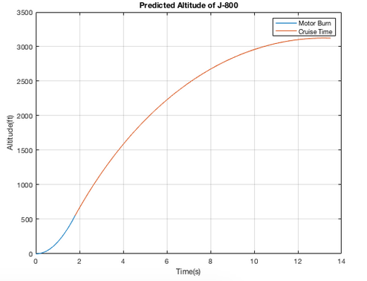 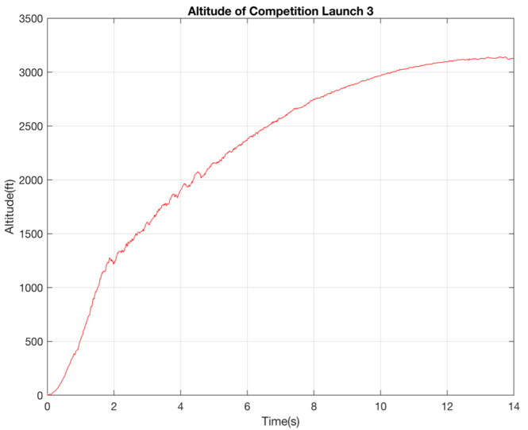

*Figure 6: J800T-L Launch #3 Predicted Altitude v Time Figure 7: J800T-L Launch #3 Actual Altitude v Time*

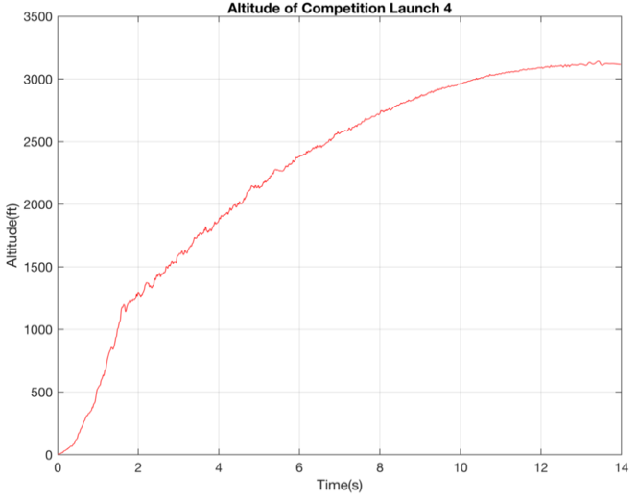

*Figure 8: J800T-L Launch #4 Actual Altitude v Time*

**Peak Velocity vs. Expectations**

Our velocity values were a little harder to troubleshoot as to why they were lower than the predicted values. The MATLAB code uses net thrust and a changing value of mass to calculate its acceleration. The rocket’s weight decreases as the motor burns and the net thrust changes based on the increase of drag and the decrease in mass. The code then uses this value of acceleration to calculate its velocity as a function of time. This method does not exactly mirror the thrust curve of the J-800T-L, but it does provide a close approximation. The velocity value is lower than the predicted values due to the differences in the applied thrust over time. The motor realistically provides far less thrust towards the end of the burn time than we are predicting, which would explain the differences in the max velocities.

*Table 2: Predicted vs. Actual Velocity*

|  |  |  |  |
| --- | --- | --- | --- |
| Flight Number | Predicted Velocity (ft/s) | Actual Velocity (ft/s) | Percent Error (%) |
| 1 | 579 | 569 | -1 |
| 2 | 579 | 577 | -0.3 |
| 3 | 579 | 544 | -6 |
| 4 | 579 | 539 | -7 |

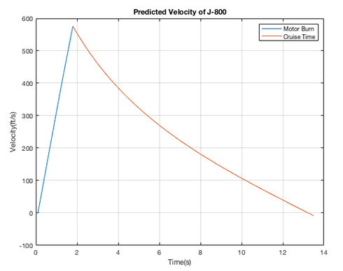 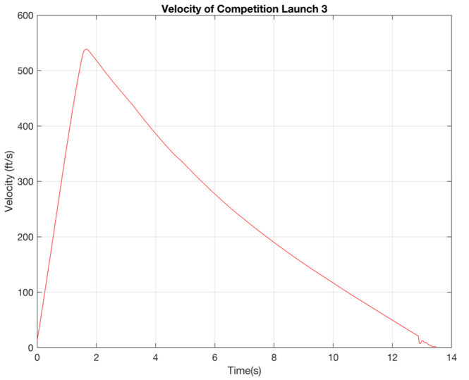

*Figure 9: J800T-L Predicted Velocity v Time Figure 10: J800T-L Launch #3 Actual Velocity v Time*

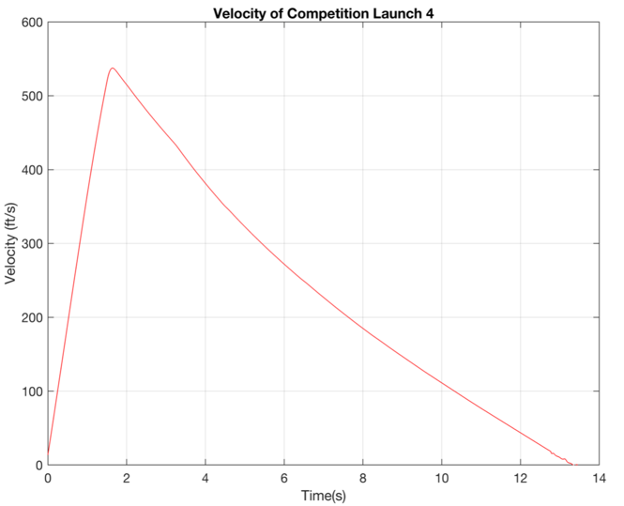

*Figure 11: J800T-L Launch #4 Actual Velocity v Time*

**Peak Acceleration vs. Expectations**

The average percent error between flights one and two is 12%. This is most likely as high as it is due to the system not activating which in turn induced less drag. Flights three and four had an average percent error of 5 percent, which is much closer to the predicted values most likely because the roll control system activated like it was supposed to.

*Table 3: Predicted vs. Actual Acceleration*

|  |  |  |  |
| --- | --- | --- | --- |
| Flight Number | Predicted Acceleration (ft/) | Actual Acceleration (ft/) | Percent Error (%) |
| 1 | 348 | 382 | 9 |
| 2 | 348 | 402 | 15 |
| 3 | 348 | 367 | 5 |
| 4 | 348 | 366 | 5 |

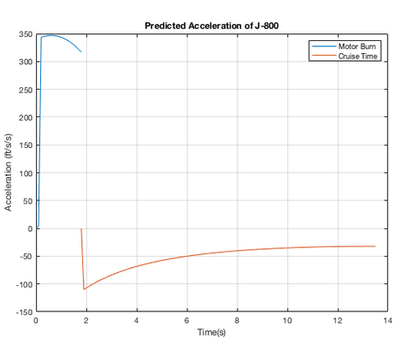 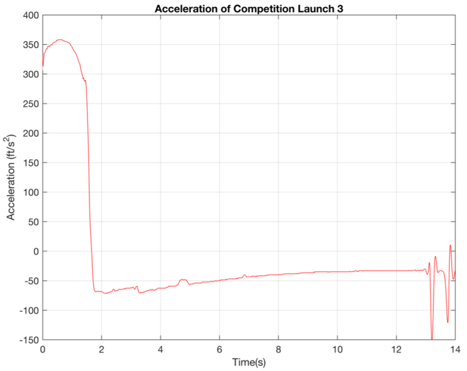

*Figure 12: J800T-L Predicted Acceleration v Time Figure 13: J800T-L Launch #3 Actual Acceleration v Time*

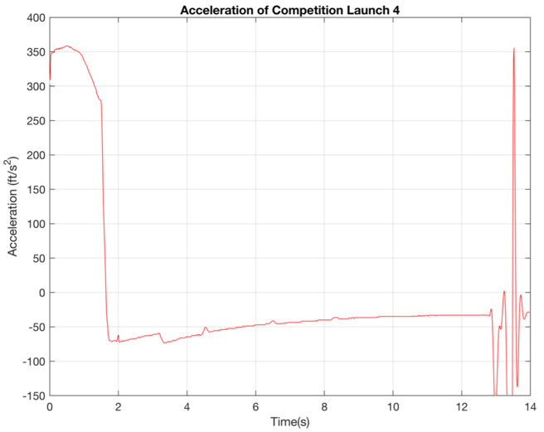

*Figure 14: J800T-L Launch #4 Actual Acceleration v Time*

**Descent Velocity Performance vs. Expectations**

Descent rates for each flight were recorded below 24 fps according to our Altimeter 3 data. Below is a graphical representation of the differences in descent rates in each flight for both parachutes.

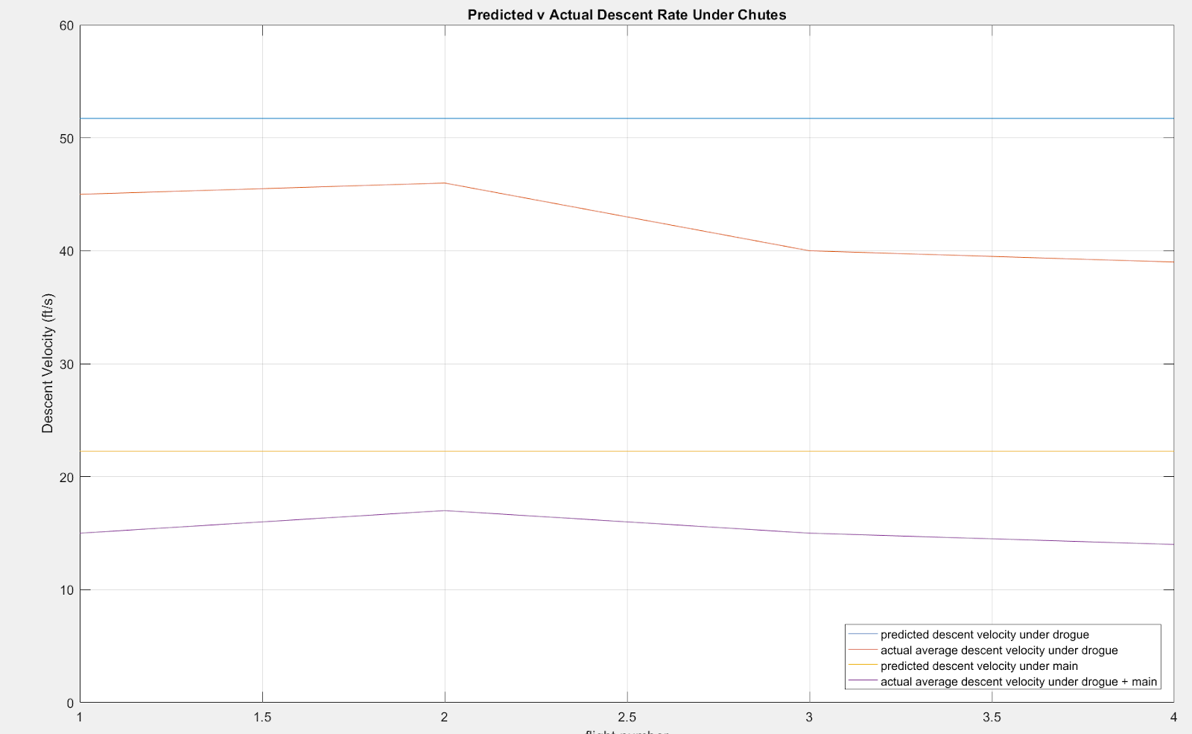

*Figure 15: Predicted v Actual Parachute Descent Rates*

Using the descent equation below, we were able to predict our rocket’s average descent rate. The rocket weighed 15.4 lbs. at the competition, used a 42-inch drogue chute and an 80-inch main chute.

**[Eqn. 1]**

Where;

Equation 1 then becomes: *(for a descent rate of only);*

, *Where;* **[Eqn. 2]**

This equation gave an average descent rate of 20 fps. Our competition descent rates were averaged at 16 fps.

**Active Roll System Data Collection & Analysis**

**Roll Monitoring Data Presentation**

*Table 4: LED Instruction*

|  |  |
| --- | --- |
| Solid red (On Pad) | System Armed, On Standby |
| LED Off | Boost & Safety Delay |
| Green | Target Angle Reached |
| Blue | Counter-Clockwise Roll |
| Red | Clockwise Roll |

Unfortunately, no roll orientation data was collected due to system anomalies and our SD card falling out of its reader during motor burnout. The data collection system worked as expected during test launches.

**Quality of Flight Video**

Launches were recorded on a Foxeer Legend 1 at 1080p. Video throughout each launch is stable with no major issues. Movement of the canards, changes in LED color, and the large tarp compass on the field are all visible throughout each flight.

**Flight Video Links**

Launch 1 -  Error (System did not activate): https://drive.google.com/file/d/1XxzT01Q77HVuMWUkM4IKc4SucCwSYo4e/view?usp=sharing

Launch 2 -  Error (System did not activate):

https://drive.google.com/file/d/13aLo0xqab9-u-h6E1Xf8ekjNrXcUnjzW/view?usp=sharing

Launch 3 - Null Roll:

https://drive.google.com/file/d/1qFBVZpuXkQhgS20QnnNAvjNgrg4aChtY/view?usp=sharing

Launch 4 - Controlled Roll:

https://drive.google.com/file/d/1-QlMKJNTr_GrQRuvM7PidUl2WbTKiezN/view?usp=sharing

**Data Interpretation & Comparison to Expectations**

Overall performance from the control system went well. The first and most noticeable thing is our inability to roll the rocket counter-clockwise. In our testing, we first attributed this issue to the system. After simplifying the controls as much as possible, the issue remained. We then determined that the canards were not providing enough force to counter the natural roll, however, we were too close to the competition to make new canards. On the J800 motors, it seemed that the system was more capable of counter the natural roll of the rocket than our lower power test motors. In both competition flights, the system slowed roll better than we saw in our test launches, possibly because of the added torque applied by the fins as programed by the servo.